Lab 2 Report
(MinHeap + Huffman Encoding)
Ashraf Saleh Mohamed Aly (20)

Sample Runs:

text file :

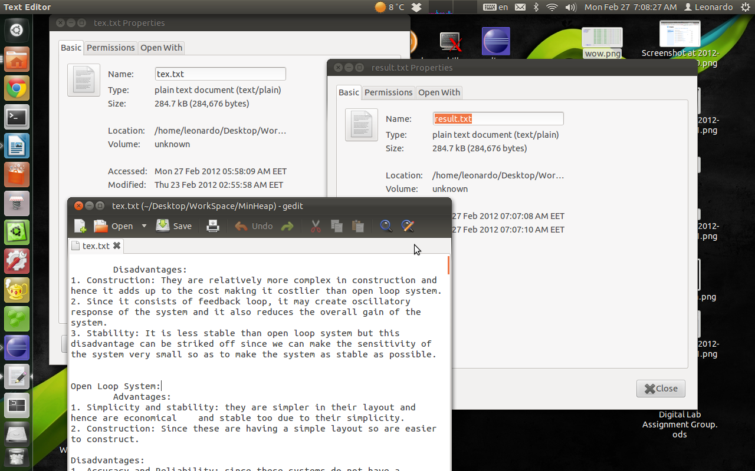
time
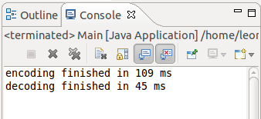

Picture:

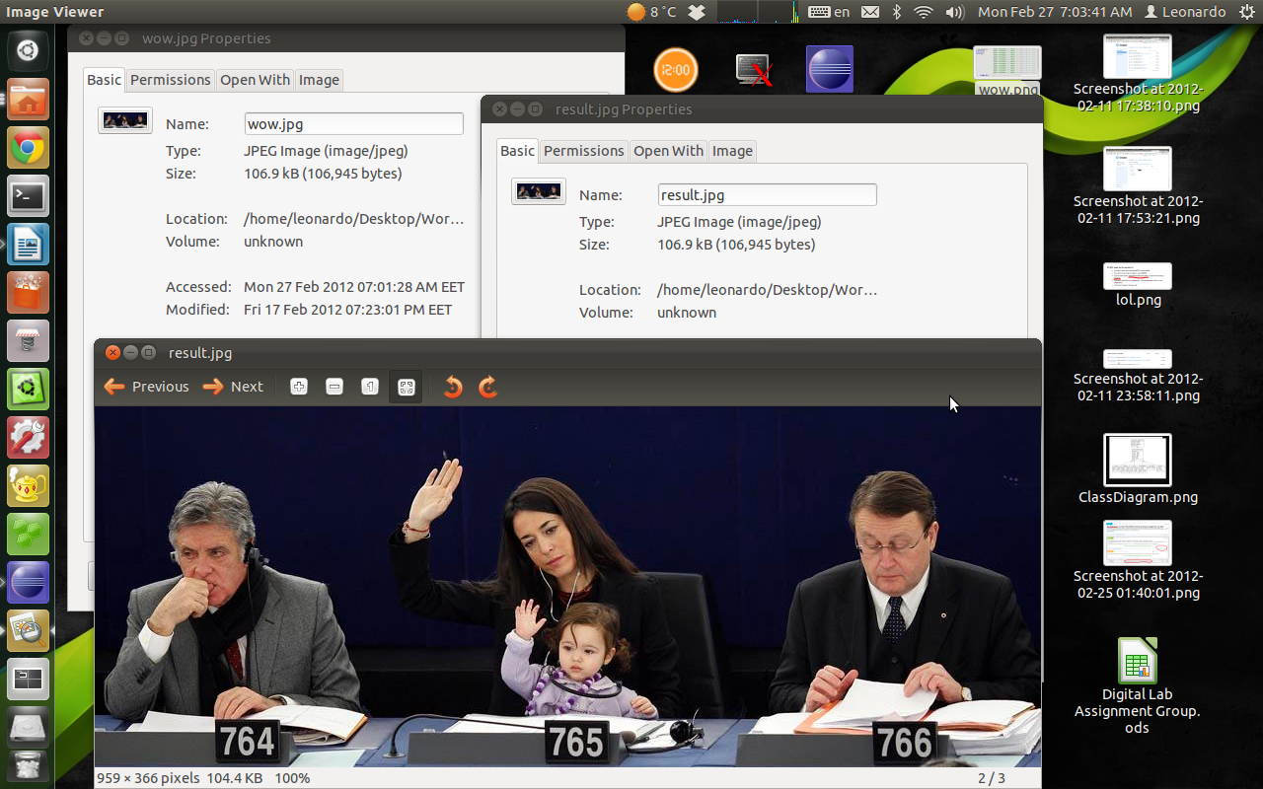
time
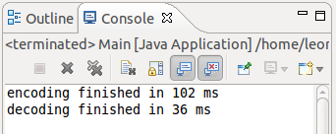

Video:

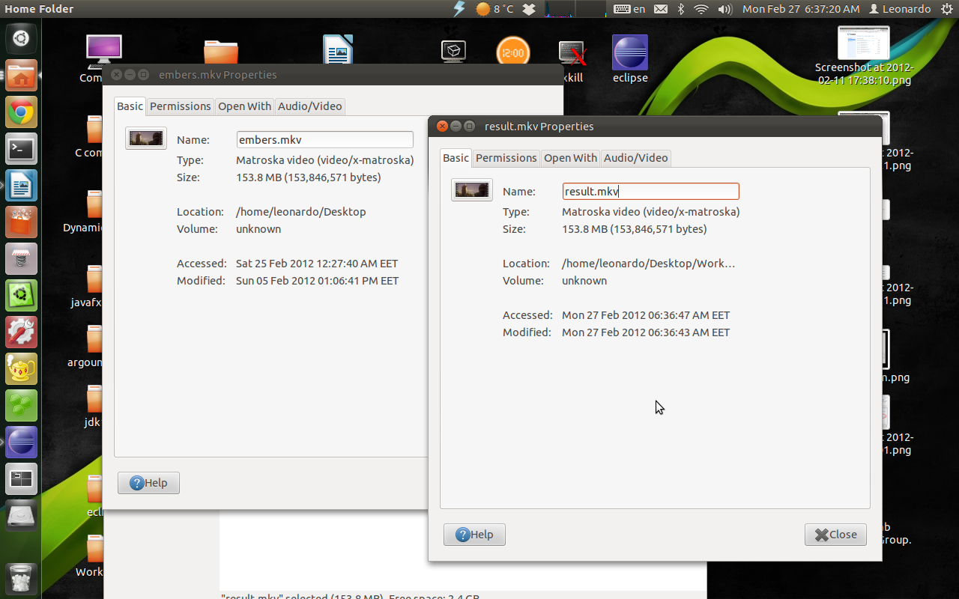
time
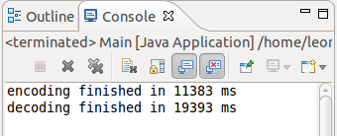

Executable:

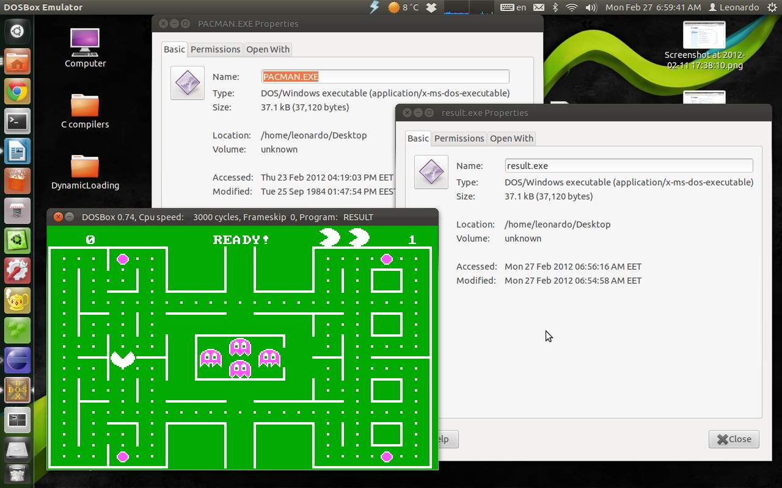

time
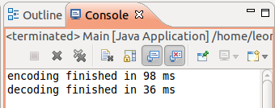

Chosen Code Fragments :
MinHeap Class :
/**
* @param element
* insert a new node then adjust the heap
*/
public void add(E element) {
heap.add(element);
int parent = (top - 1) / 2;
int current = top;
E temp;

while (parent >= 0 && element.compareTo(heap.get(parent)) < 0) {
temp = heap.get(current);
heap.set(current, heap.get(parent));
heap.set(parent, temp);
current = parent;
parent = (parent - 1) / 2;
}
top++;
};

/**
* @param element
* deletes the all the nodes containing the given element then
* reheapify the heap
*/
public void remove(E element) {
int i;

while ((i = search(element)) >= 0) {
heap.set(i, heap.get(--top));
heap.remove(top);
heapify(i);
}

}

/**
* @param i
* heapify the sub tree whose root is at index i in the heap
*/
private void heapify(int i) {
int minIndex;
E temp;

while ((i + 1) * 2 - 1 < top) {

if ((i + 1) * 2 < top) {
minIndex = heap.get((i + 1) * 2 - 1).compareTo(
heap.get((i + 1) * 2)) < 0 ? (i + 1) * 2 - 1
: (i + 1) * 2;

} else if ((i + 1) * 2 - 1 < top) {
minIndex = (i + 1) * 2 - 1;
} else
break;
temp = heap.get(minIndex);
heap.set(minIndex, heap.get(i));
heap.set(i, temp);
i = minIndex;
}
}

Encoder Class
public void write() throws IOException {
BufferedOutputStream bw = new BufferedOutputStream(
new FileOutputStream(Main.compressed));
br = new BufferedInputStream(new FileInputStream(Main.source));

ObjectOutputStream ob = new ObjectOutputStream(bw);
ob.writeLong(bytesNo);
ob.writeObject(freq);

int readBytes;
long code;
int len;
byte[] outBuffer = new byte[Main.bufferSize];
byte currentByte = 0;
int leftLen = 8;
int count = 0;
int i = 0;

readBytes = br.read(buffer);
code = codes.get(buffer[i]);
len = codelen.get(buffer[i]);
while (true) {
if (len <= leftLen) {

code = code << (64 - len) ;
code = code >>> (64 - len) ;

currentByte = (byte) (currentByte | code<<(leftLen - len));
leftLen = leftLen - len;

i++;
if (i >= readBytes) {
readBytes = br.read(buffer);
if (readBytes == -1)
break;
i = 0;
}
code = codes.get(buffer[i]);
len = codelen.get(buffer[i]);

if (leftLen == 0) {

if (count >= buffer.length) {
bw.write(outBuffer);
count = 0;
}

outBuffer[count++] = currentByte;
currentByte = 0;
leftLen = 8;

}

} else {
currentByte = (byte) ((currentByte ) | (code >> (len - leftLen)));
code = code << 64 - len + leftLen;
code = code >>> 64 - len + leftLen;
len = len - leftLen;
leftLen = 0;

if (count >= buffer.length) {
bw.write(outBuffer);
count = 0;
}
outBuffer[count++] = currentByte;

currentByte = 0;
leftLen = 8;
}

}

outBuffer[count++] = (byte)(currentByte<<(leftLen));
bw.write(outBuffer, 0, count);

ob.close();
bw.close();
}

String bin(byte b){
String s = "";
for (int i = 0; i < 8; i++) {
if((b&(1<<7-i))==0)
s+=0;
else
s+=1;
}
return s;
}

Decoder Class
@SuppressWarnings("unchecked")
public void read() throws IOException, ClassNotFoundException {

BufferedInputStream br = new BufferedInputStream(new FileInputStream(
Main.compressed));
BufferedOutputStream bw = new BufferedOutputStream(
new FileOutputStream(Main.dest + Main.ext));
ObjectInputStream ob = new ObjectInputStream(br);
long bytesNo = ob.readLong();

freq = (long[]) ob.readObject() ;
calcFreq();

byte buffer[] = new byte[Main.bufferSize];
byte outBuffer[] = new byte[Main.bufferSize];
int n = 0;
int i = 0;
int j = 0;
int count = 0;
byte current = 0;
AbstNode<Long> node = tree;

n = br.read(buffer);
current = buffer[i++];

while (true) {

if (node.isLeaf()) {
if(--bytesNo<0)break;
outBuffer[count++] = ((Leaf<Long, Byte>) node).getElement();
node = tree;
if (count >= outBuffer.length) {
count = 0;
bw.write(outBuffer);
}

} else {
if ((current & (1 << (7 - j))) == 0) {
node = ((Node<Long>) node).getLeft();
j++;
} else {
node = ((Node<Long>) node).getRight();
j++;
}
}

if (j >= 8) {
current = buffer[i++];
j = 0;

}

if (i >= buffer.length) {
i = 0;
n = br.read(buffer);
if (n == -1)
break;
}

}
//should be 0 but i decrement in the if statement
if (bytesNo !=-1)
count+=bytesNo+1;

bw.write(outBuffer, 0, (int)(count));

bw.close();
ob.close();
br.close();

}

public void calcFreq() {
for (int i = 0; i < freq.length; i++) {
if (freq[i] == 0)
continue;
pq.add(new Leaf<Long, Byte>(freq[i], (byte) i));
}

AbstNode<Long> temp1;
AbstNode<Long> temp2;

while (pq.size() != 1) {
temp1 = pq.poll();
temp2 = pq.poll();

tree = new Node<Long>(temp1.getKey() + temp2.getKey());
tree.setChildren(temp1, temp2);
pq.add(tree);
}
decode(0, pq.poll(), 0);
}

